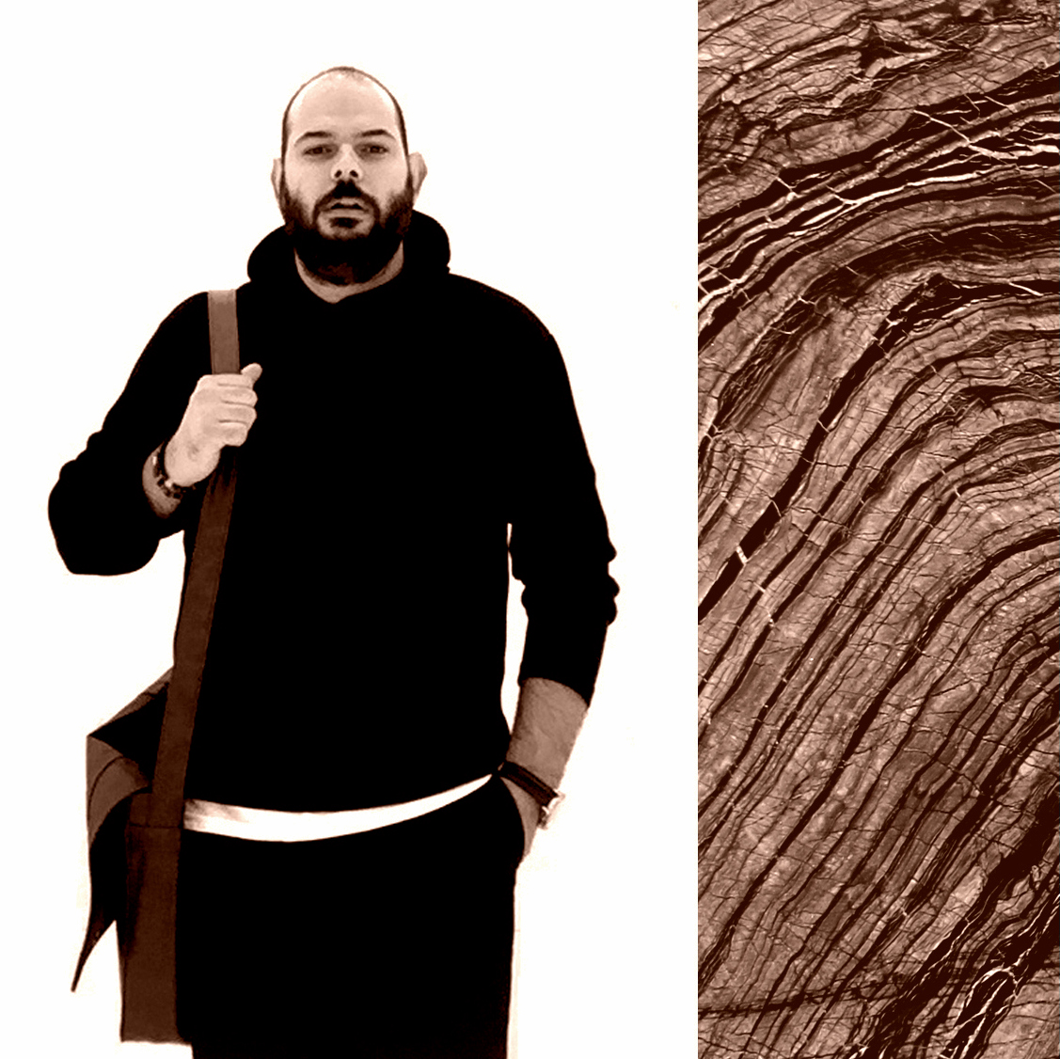
DENIZ COBANOGLU
date of birth: 17 / 04 / 1984
nationality: British / Turkish
address: 140 Residence Tower, Woodberry Grove, N4 2BS, London
portfolio / website: www.denizcobano.com
email : denizcobanoglu@gmail.com
phone : 07580 012127

Business Experience
Mega Marble Ltd. (UK)
Design & Project Manager - Feb.2019 – March.2020
- Responsible for overseeing and advising on optimisation of drawings by other members of design team on professional approach.
- Create cutting / working sheets, quality and quantity checks in overseas, taking control of production, design bespoke crates and managed total of nr166 bathrooms in 1 year for Grosvenor Square project with the most complex material (White Truffle Marble)
- Manage the design process, produce CAD drawings, create and maintain drawing registers, attendance at the relevant client design meetings.
- Available to team and managers to deal with technical queries in respect of fixing methodologies, best practise, compliance with British and European Standards.
- Liaison with the factory and other production centres in respect of production details and deadlines.
- Providing accurate information to the commercial team for valuations and final accounts.
- Visits with clients for material selection and preparation of range reports from factory / marble quarries.
- Reporting to Contracts Director on progress and financial performance on each project throughout.
- Creating positive working relationships with client and contractor teams to support the development of repeat work/tenders and optimise the brand image.
- Advising on the selection of natural stones used and other aspects of procurement.
- Managing processes relating to the project's design to ensure that everything is delivered to schedule and budget, working very closely with estimators, quantity surveyors, site managers.
- Reviewing and advising on designs, ensuring they meet regulatory and legislative requirements and the client’s brief.
Tramar Group Ltd. (UK)
Design Manager - Dec.2017 – Feb.2019
- Establishing design, plan, and refined the architectural concepts along with furnishing and interior designing.
- Estimating material requirements, costs and presented design to client for their approval.
- Creating 3D photorealistic CGIs with current Natural Stone selections and making presentations to contractors, main clients / architects.
- Guiding clients on material choice, colour coordination, space utilisation, cost cutting, and use of natural stones as an architectural theme.
- Responsible for interacting with clients to determine factors like budget and architectural preferences.
Oblion | Stone Projects Ltd. (UK)
Design and Project Manager - Company Partner - Nov.2013 – Dec.2017
- Selecting, or having input into the selection of, specialist subcontractors or other organizations that will help complete the project work.
- Chairing design and project site team meetings, writing reports and giving presentations.
- Schedule and coordinating internal and external personnel to complete the project.
- Leading the design department on stone projects for luxury hotels, restaurants, offices and residentials.
- Preparing samples promoting the company and its works through written or web-based mediums.
- Responsible for initial project requirements, site visits, 2D drawings, 3D presentations (CGI)
- Visiting architects and contractors to develop new relationships with companies who may benefit from an added value conceptual stone design to installation services.
- Developing branding / design and marketing strategies.
Decorium UK Ltd. (UK)
Interior Architect - Sept.2008 – Oct.2013
- Providing perspectives, technical drawings including electric & lighting plans, layouts, marble furniture and stone accessorize details.
- Preparing working sheets for the production department.
- Calculating and forecast material requirements and costs with the estimators for the approval from the clients.
- Responsible for site surveys.
- Designed company`s 2 other showrooms in London.

Skills and Knowledge
Technical:
- 12 years of experience on AutoCad, 3Ds Max + VRay, Adobe Photoshop.
- Strong design skills / hand drawing sketching.
- Excellent knowledge of World-wide Natural Stones / quarries / production technologies.
Professional:
- Project management skills including quality control, overseeing the production process and control installation stage.
- 12 years of professional interior design experience in Natural Stone Industry.
- Developed great relationship with stone quarries, suppliers and production centers in Turkey, Italy, China and India.

Languages: English (Fluent), Turkish (Native)

Documents: Full UK driving license, CSCS card (doc.no: 06479807)

Education
2003 - 2007 Anadolu University | Turkey
Interior Architecture
Award, First Class Honors

1999 - 2003 Antalya Fine Arts Collage | Turkey
Graphic and Product Design

Design Awards
• Natural Stone Design Competition / 2013. Istanbul, TR
2nd place – design ref: “stoneraphy”
• Siemens. Life Design / 2010. New York, US
Finalist - design ref: “synapse”

Interests
• Photo shooting, playing table tennis and cycling together with my 10 years old son.

Selected Projects in Portfolio

No1 Grosvenor Square / London. 2019 Chelsea Barracks Block16 / London. 2019
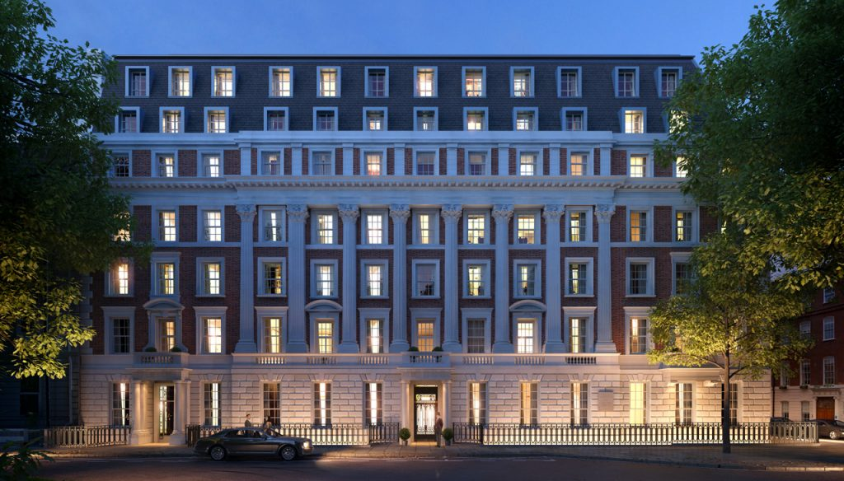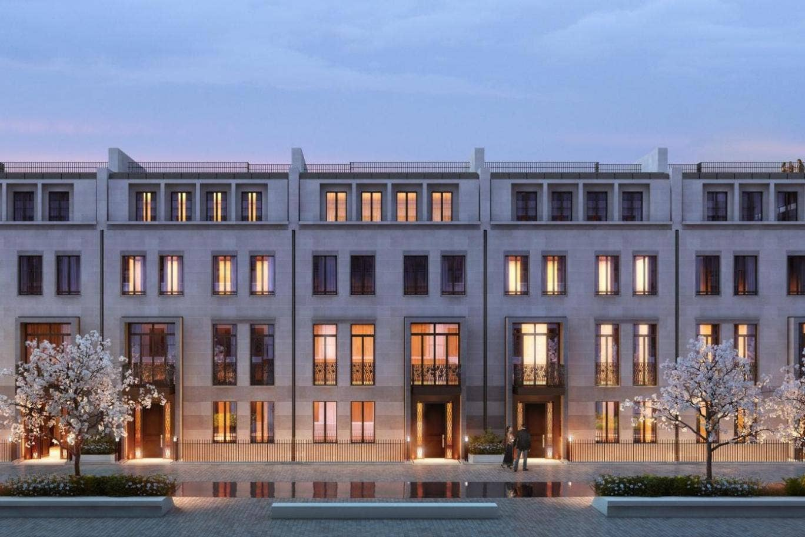
Chotto Matte Restaurant / Miami. 2018 Belz Synagog / London. 2017
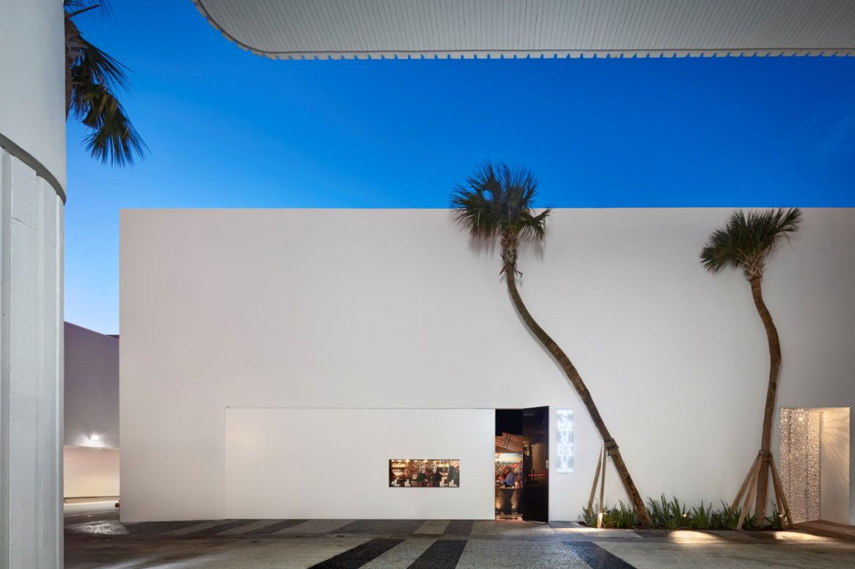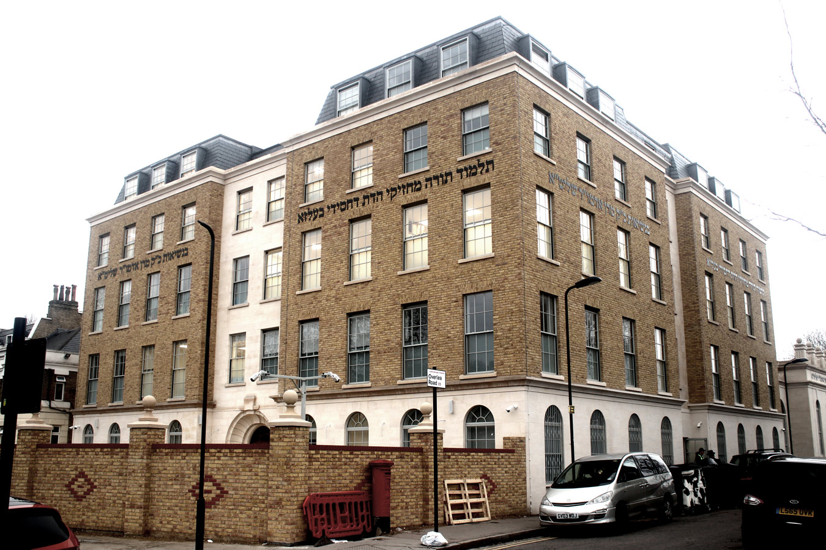
Pantheon Marble Showroom / Istanbul. 2016 Private Mansion / Ipswich 2015
